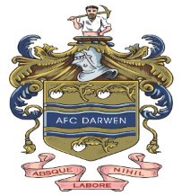
AFC Darwen Whistleblowing Policy
Reporting your concerns about the welfare of a child or young person - Safeguarding is everyone’s responsibility. If you are worried about a child it is important that you report your concerns - no action is not an option.
If you are worried about a child then you need to report your concerns to AFC Darwen Welfare Officer
If the issue is one of poor practice they will either:
  - deal with the matter themselves or
  - seek advice from the LFA Welfare Officer
If the concern is more serious - possible child abuse - they will, where possible, contact the LFA Welfare Officer first, then immediately contact the Police or Children’s Services
- If the child needs immediate medical treatment arrangements will be made to take them to a hospital or call an ambulance and tell them this is a child protection concern. The matter will immediately be reported to the LFA Welfare Officer
- If at any time are not able to contact your Club Welfare Officer or the matter is clearly serious then you can either:
      - contact your LFA Welfare Officer direct
      - contact the Police or Children’s Social Care
      - call the NSPCC 24 hour Helpline for advice
Useful Numbers:
AFC Darwen Welfare Officer: 01254 406903
Lancashire Football Association Welfare Officer: 01772 624000
NSPCC 24 hour Helpine -
- Telephone: 0808 800 5000
- Email: help@nspcc.org.uk
- Text 88858
Police: 101
CEOP: -Child Exploitation and Online Protection (CEOP) Centre address is:
Child Exploitation and Online Protection Centre
33 Vauxhall Bridge Road
London SW1V 2WG
Please be advised that the CEOP Reception is manned from 09:00 till 17:00, Monday to Fridays.
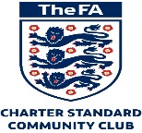
Contact them by
- online contact form: : https://www.ceop.police.uk/safety-centre/
- Telephone: +44 (0)870 000 3344
Children Social Care:
Phone Number(s) 01254 666400 (8:30am and 5:00pm, Monday to Friday)
Fax Number(s) 0845 606 6654
E-mail: CYPReferrals@blackburn.gov.uk
Extra Information
Out of hours – Emergency Duty Team: 01254 587547

